Guide for Windows Movie Maker
Initially, this program should be installed on the PC. This can be done through http://filehippo.com/download_windows_live_movie_maker/download
Open the program Windows Movie Maker.
The following image will appear on the screen of your PC.
Dropdown Menu
Dropdown Menu
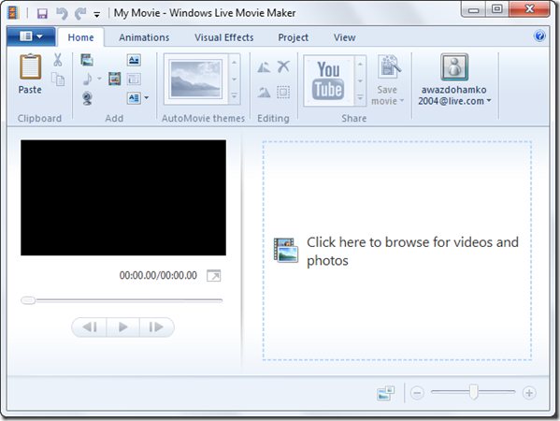
Toolbar Ribbon

Preview Window
Layout Table

Zoom in Time Scale
Player controls

Let’s start! At first, you must add videos or photos.
- Add videos and photos
From the Ribbon toolbar click the Add videos and photos. You can select as many files as you want.
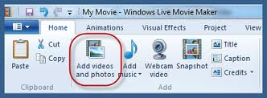

- Adding transitions from one image (or video) to the next in order to make the project more attractive.
From the Animations tab on the dropdown menu,
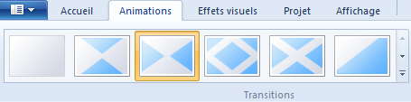

- Adding effects on a photo.
Click the animation tab in the drop-down menu and then choose from the Pan and zoom
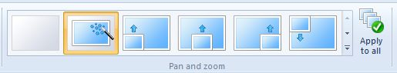

- Adding Visual Effects on a photo
For Visuals Efftects tab in the drop-down menu.
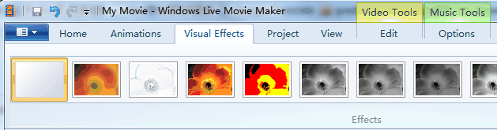

- Add music on you film to make it more interesting and lively
Click Add music and then retract it from the file that is already stored.
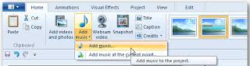

- Add a title on you film
Click the Title icon to enter title for your movie.
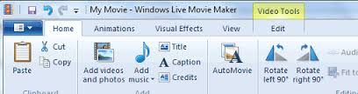

Immediately the following image will appear, and you can configure how you want your title to appear.
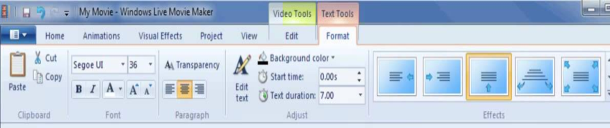

- Adding caption on the pictures of your film.
Click on the caption icon to enter a caption on your image.

- Adding end credits to your film to show the producers of the film.

- Play: To play the movie that you have made, press the button on the playback controls.

- Save project:
Open the drop-down menu (left) and select Save project as to save your work.
Once your work has been competed save it as movie from save movie tab
